AC CIRCUITS
- Determine the average value, RMS value, Form factor and peak factor of a pure sinusoidal Waveform?
- Find the average value and RMS value of a full wave rectified sine wave.
- Find the form factor of the half wave rectified sine wave shown in fig(A):

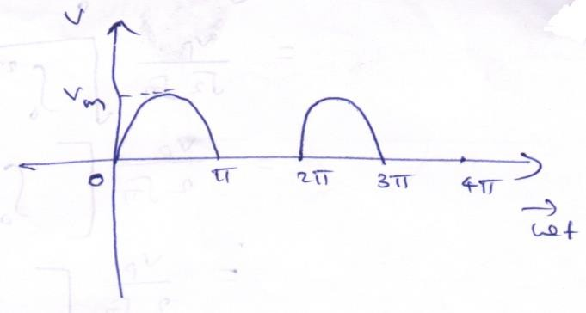
Fig. (A)
- The full wave rectified sine wave shown in fig (B) has a delay angle of 60. Calculate the average value and RMS value?
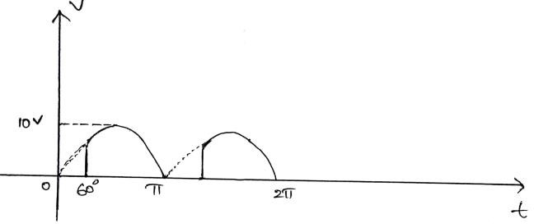

Fig. (B)
- A 1KΩ resistor is connected in series with an inductance of 50mH across a 230V, 50HZ AC Supply. Find (a) Inductive reactance (b) Impedance (c) Current (d) Phase angle (e) Voltage drop across resistance (f) Voltage drop across Inductance.
- A 50Ω resistor is connected in series with a 25μF Capacitor across a 230V, 50HZ AC Supply. Find (a) Capacitive reactance (b) Impedance (c) Current (d) Phase angle (e) Voltage drop across resistance (f) Voltage drop across Capacitance (g) Power Factor.
- A resistance of 50Ω, inductance of 29.8mH, Capacitance of 3.4μF Capacitor are connected in series across a 200V, 250HZ AC Supply. Find (a) Impedance of circuit (b) Current (c) Power consumed in the circuit (d) Power factor (e) Voltage drop across resistance (f) Voltage drop across Inductance (g) Voltage drop across Capacitance. Also draw the phasor diagram for the circuit. ]
- A Capacitor of 1μF is connected across an AC Voltage of V=170 sin (400t). Determine (a) Capacitive Reactance (b) Sinusoidal expression for current (c) Maximum current.
- A Pure Inductive coil allows a current of 10A to flow from a 230V, 50HZ AC Supply. Find (a) Inductive Reactance (b) Inductance of the coil (c) Power Absorbed (d) Sinusoidal equations for Voltage and Current.
- An AC Circuit consists of a pure resistance of 20Ω and it is connected across an AC supply of 230V, 50HZ. Find (a) Current (b) Power Consumed (c) Sinusoidal equations for Voltage and Current.
- Find the form factor for the following waveform shown in fig(C):
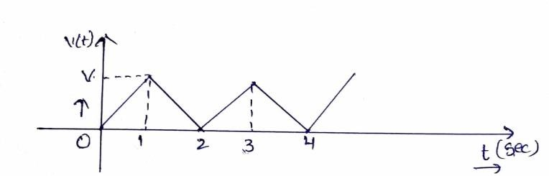
Fig. (C)
- Find the form factor for the following waveform shown in fig(D):
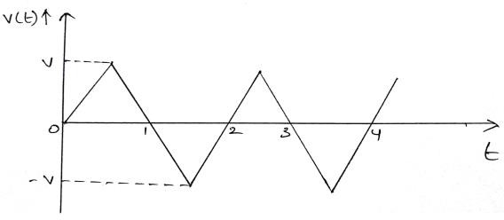

Fig. (D)
- Short answer questions
- Expressions for
- Average and RMS voltage
- Voltage and current relations in passive elements (R, L, C)
- Voltage and current relations in R, L, C combinational circuits
2. Define
- Active power
- Reactive power
- Apparent power
- Power factor
- Form factor

